SALAYO, HEAVEN GRACE D. BSIT-4B
LABORATORY CHECKLIST
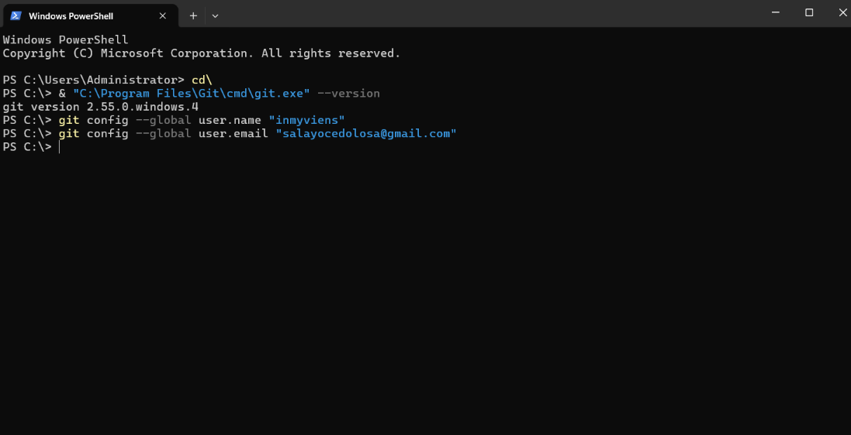
- Git installed/configured

- GitHub repository created
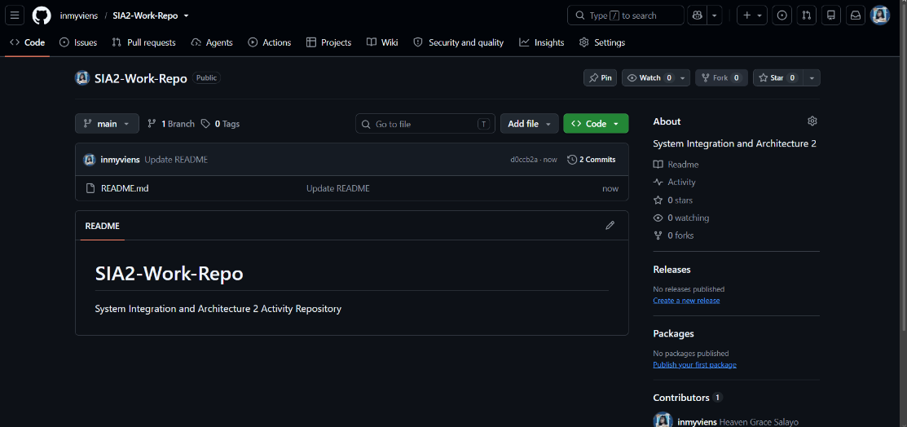

- Install/ Configured VS Code
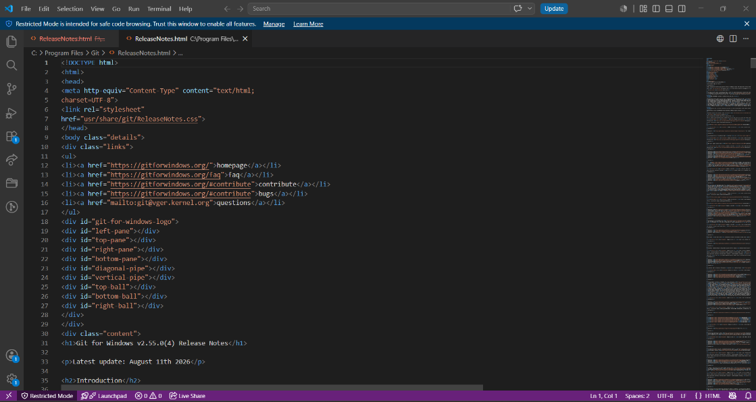

- API testing tool working
- Programming Environment Working
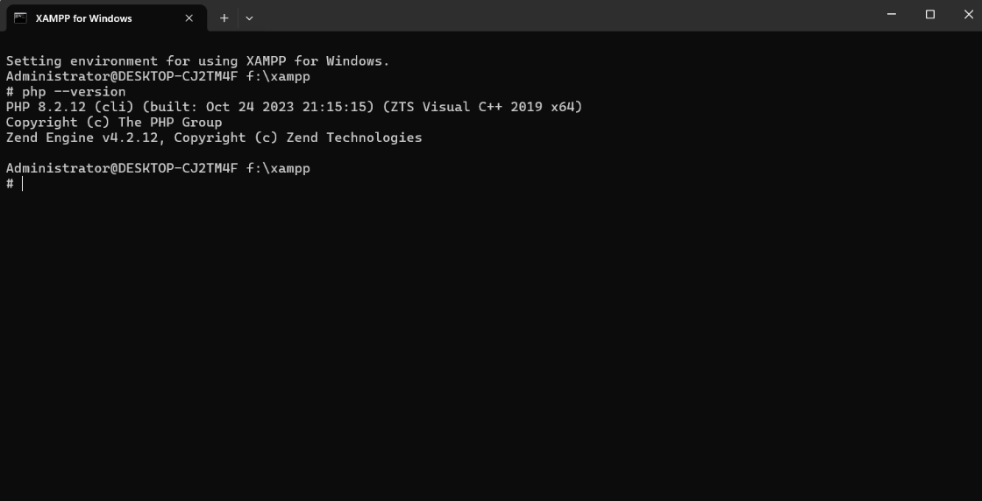

- Database Working
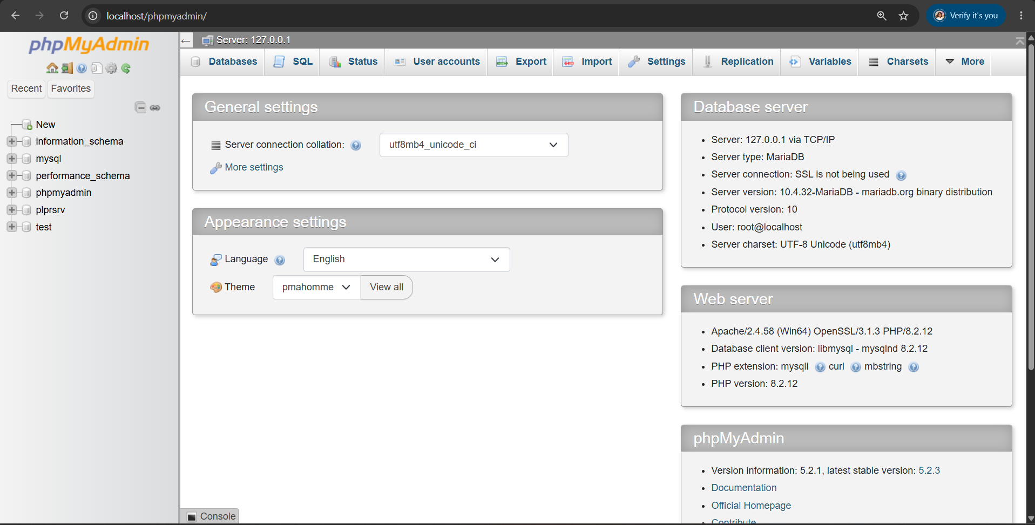
- Docker installed/available
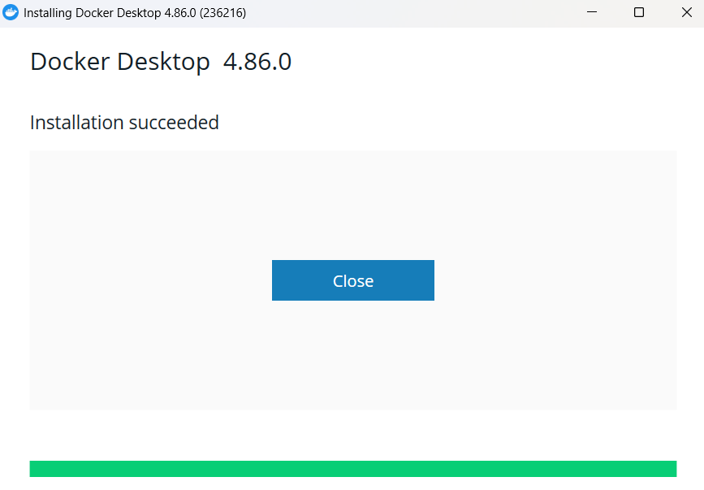

- First Git commit completed
- First API request completed

